Making a map to use in RVIZ

I have an outdoor robot that uses GPS for localization. The instructions below show how to create a map using a Google Map screen capture as the starting point an adding obstacles using a presentation tool like Power Point.

1. Choose the location you want to create a map for and locate it in Google Maps.
2. Look at the area and choose a place where you want the tractor to start in RVIZ. Because we use GPS to localize the tractor we use the gps_odom.py program to translate lat/lon into an odom statement. This program uses a reference point (a.k.a. an origin) to calculate the x, y position from that origin. Choose a point to be the origin and capture the lat/lon of that point. You can see below I put a blue cross where I would start. Don’t choose the middle of an open field without any identifying marks. It will make it harder to be accurate on the lat/lon of the position.

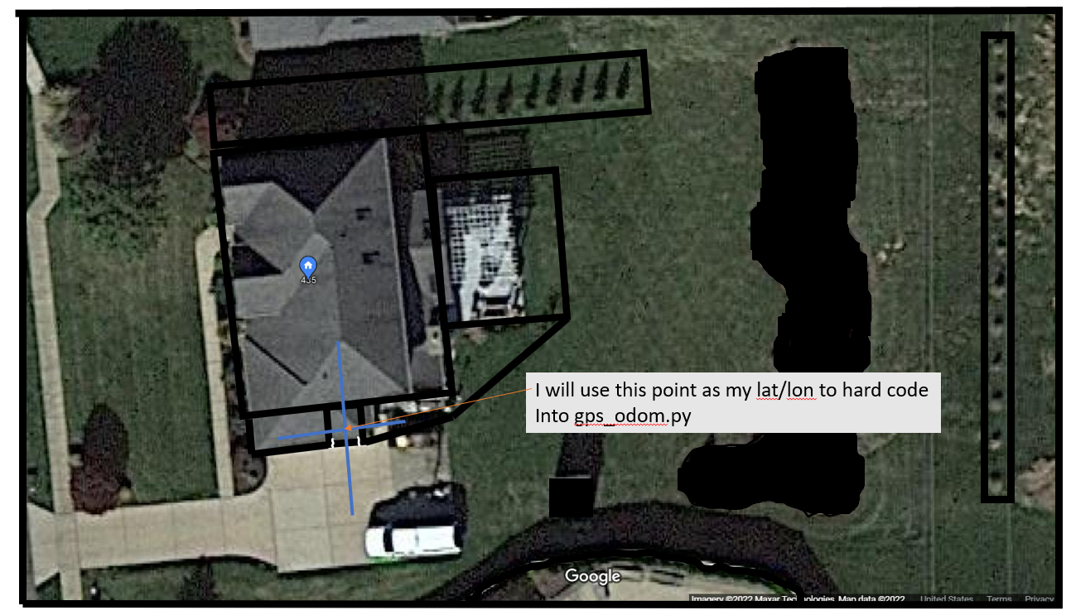

I am going to refer to my gargage because I can see it plainly. I checked what Google had for the point, but for inputing into the program I used the RTK GPS position from the fix topic. # garage: 40.345309421806114, -80.12893254116138
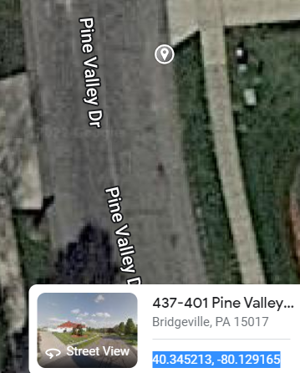

- Decide where you want to begin the lower left corner of the screen capture. Make note of that lat/lon. 40.345213, -80.129165
- Take a screen print of the location from Google Maps
- 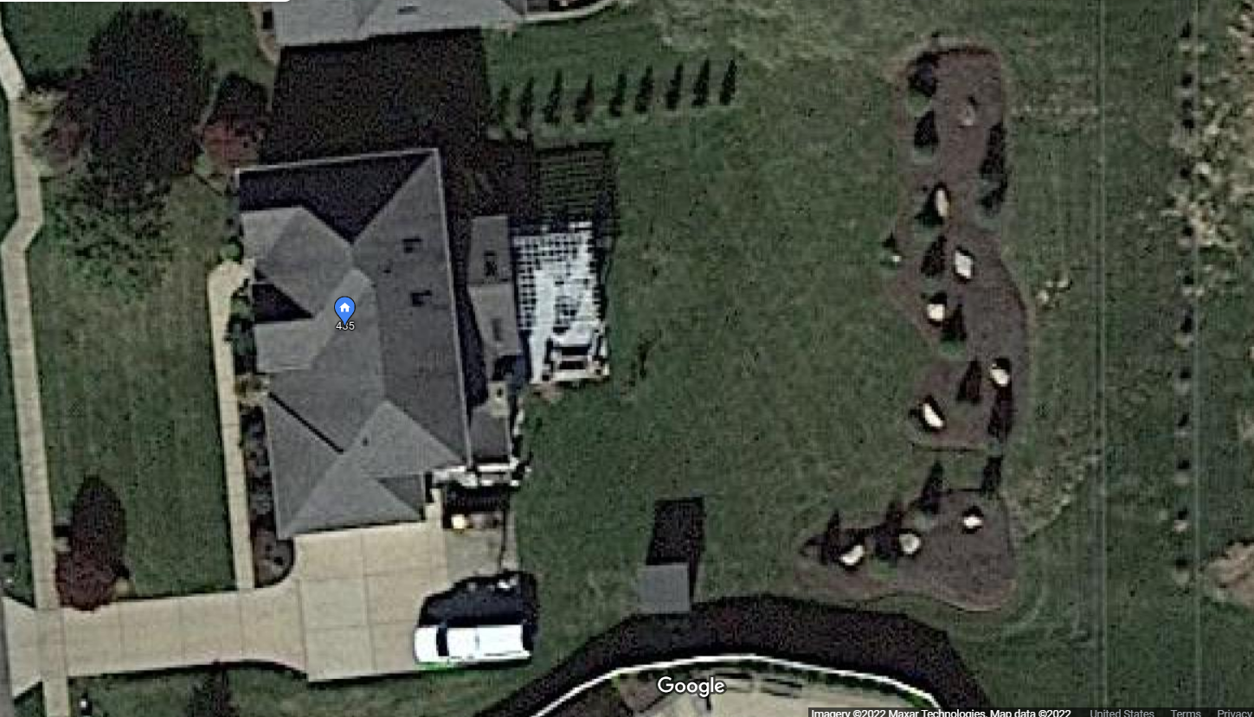
- Save that image to be traced
- I saved the clip into OneNote and then saved the image as 435_Pine_Valley.png
- As best you can, use Google Map measuring device to determine the width of the property you captured in the image
- 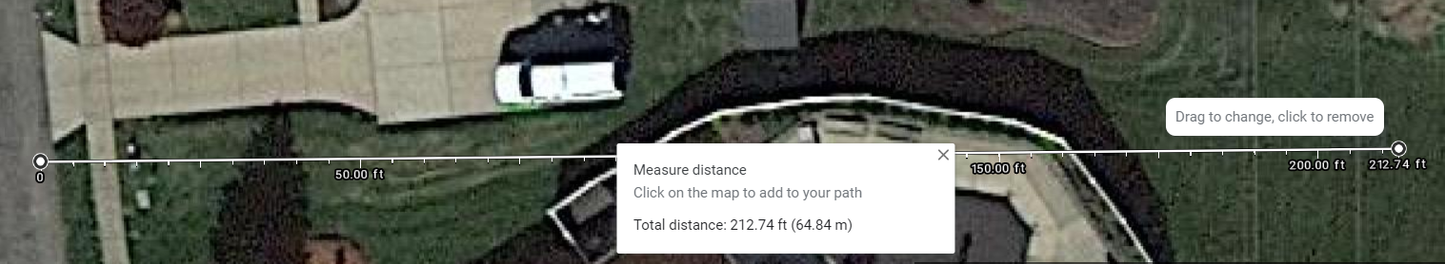
- We need to figure out the origin and resolution. Resolution is the ratio of pixels to meters.
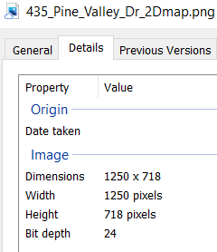 | - 212.74 feet  - 212.74ft X .3048 = 64.84315m  - 64.84315 (meters) /1250 (pixels) = 0.05187452  - Resolution = 0.05187452
- In PowerPoint, Import the .png file
- Use boxes and highlighter in black to outline barries (i.e. no-go areas). I started with thick lines around the edges.
- 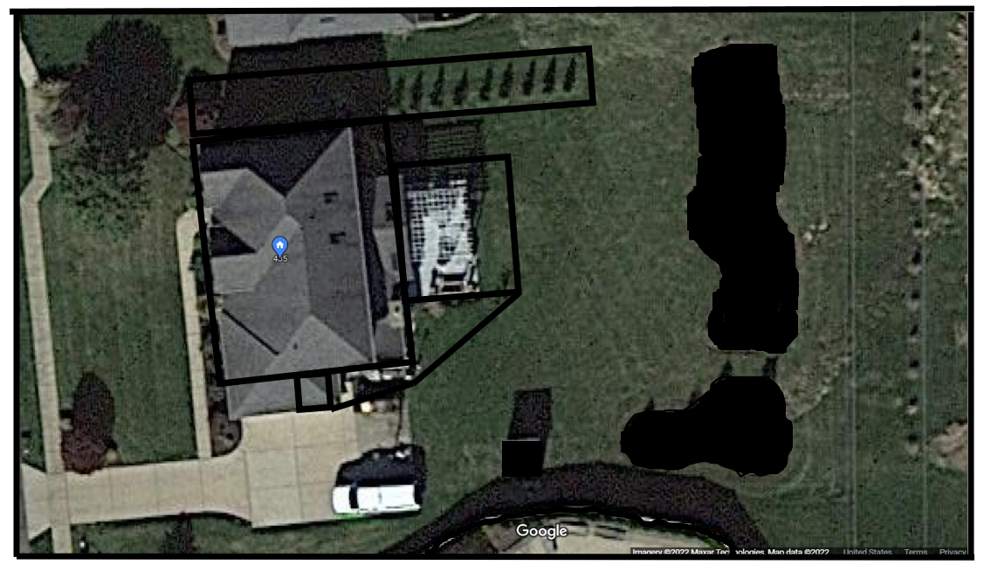
- In PowerPoint Copy slide to a new slide
- Delete the satelitte image from the slide
- 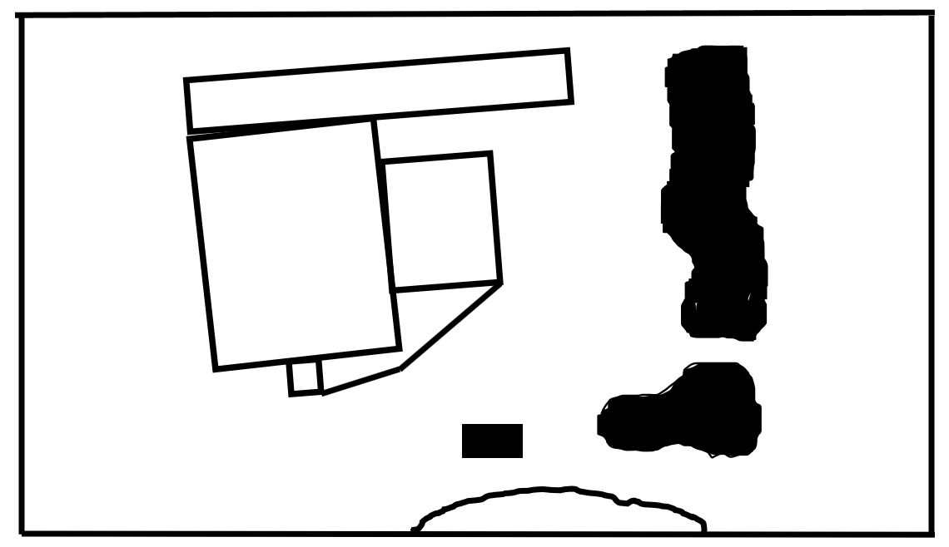

Copy .png file into the map folder (i.e.
/home/al/ros1_lawn_tractor_ws/src/ackermann_vehicle/maps
Copy a previous farm yaml file; Rename it to the map you are creating.
Update the file with name of the .png image and resolution calculated above (e.g. 0.05187452)
In nav_newteb.launch change line 20 to reference the new .yaml file and map

Determine the lower left position in x, y meters for the origin statement (origin tag in the yaml)
Update the origin statement. Because the starting position is to the right of the lower left corner the values will be negative in the origin statement.

I have a helper program to calculate these values for you. It is located at:
/home/al/ros1_lawn_tractor_ws/src/ackermann_vehicle/nodes/map_tool_convert_latlon_to_xy.py
Open the program and edit the lat/lon positions to calculate the distance.

Update GPS_ODOM.py with GPS coordinates of starting position

Change the statement below in ros1_nav.launch for the map server
args="$(find lawn_tractor_sim)/maps/farm.yaml" output="screen">

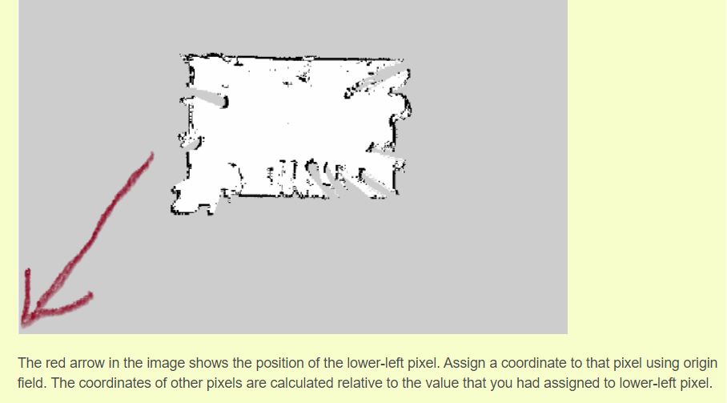
Ref: https://answers.ros.org/question/322919/to-understand-the-concept-of-origin-field-from-map_server/

origin : The 2-D pose of the lower-left pixel in the map, as (x, y, yaw), with yaw as counterclockwise rotation (yaw=0 means no rotation). Many parts of the system currently ignore yaw. link

Original:
#changes by sam
image: ros_farm_v01.png
resolution: .1
origin: [-30.0, -30.0, 0.0]
negate: 0
occupied_thresh: 0.65
free_thresh: 0.196
Updated:
image: 435_pine_valley_rviz.png
resolution: 0.05187452
# [x, y, z] x appears to be East/West; y is North/South
origin: [-26.0, -14.0, 0.0]
negate: 0
occupied_thresh: 0.65
free_thresh: 0.196

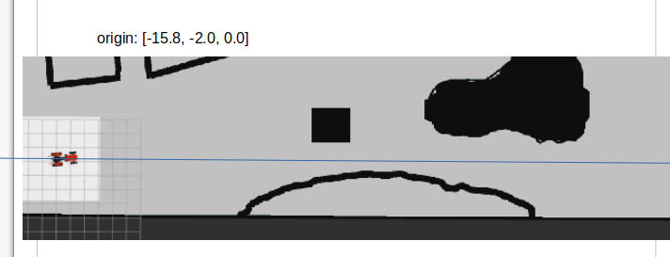

I tried multiple settings until I was happy. I copied the RVIZ image into a slide and added the blue line to see if I liked the position.

I have not tried it, but this offers a .py script that will input a .png file and using input parameters it will generate a .yaml and .pgm file.
https://www.youtube.com/watch?v=ySlU5CIXUKE
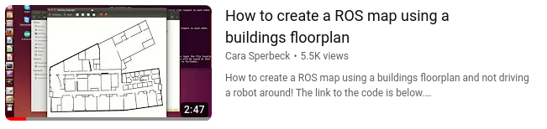

Additional reference info:
https://automaticaddison.com/how-to-create-a-map-for-ros-from-a-floor-plan-or-blueprint/

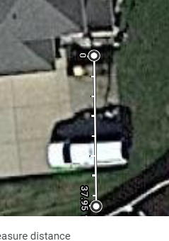 | 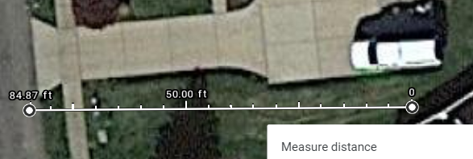

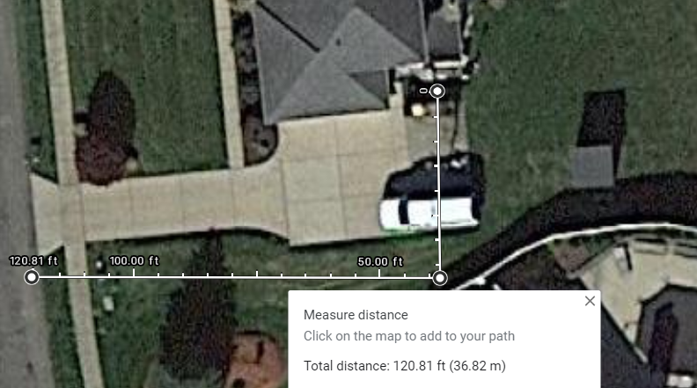

12/22/22

$ cd /home/tractor/catkin_ws/project_support_files/python
python3 test_convert_ll2xy.py
lower left delta
x: -19.63735958863981
y: -10.897022941149771

Visually I came up with
origin: [-20.2, -11.0, 0.0] # need y to come down a .5 more

